Frequently Asked Questions - 2016 Parade of Homes

What is the Parade of Homes?
The 2017 Parade of Homes is a showcase of 28 show homes in Saskatoon and Martensville. All homes were built by members of the Saskatoon & Region Home Builders’ Association.

What dates does the Parade of Homes run?
The Parade of Homes runs for an six-week period, from August 8 – September 17, 2017.

What time is the Parade of Homes open?
Parade of Homes hours of operation are as follows:
Monday – Thursday: | 2pm – 5pm (including stat holidays)
Saturday & Sunday: | 7pm – 9pm
Friday: | Closed

Who puts on the Parade of Homes?
The Saskatoon & Region Home Builders’ Association (SRHBA) is a professional association with over 60 years of experience as the voice of the residential construction industry in Saskatoon and area. Our members include new home builders, renovators, land developers, trade contractors, product and material manufacturers, building product suppliers, lending institutions, insurance providers, and other service professionals. For more information on the SRHBA please visit: http://saskatoonhomebuilders.com/

How many builders are participating in this year’s Parade of Homes?
There are 16 professional builder members of the SRHBA who have built homes for the 2017 Parade of Homes. For a complete list of builders and their contact information, visit paradeofhomesonline.ca.

Who should attend the Parade of Homes?
The Parade of Homes is great for anyone looking to:
- Explore what options are available when buying a new home in Saskatoon & Region
- See the latest trends in home design and decorating
- Get inspiration for a home renovation project
- “Try on” the various communities one can choose from when purchasing a new home
There will also be specialized events and contests to participate in throughout the parade. Please go to paradeofhomesonline.ca for the most up-to-date information on these events and contests.

What is new and exciting with the 2017 edition of the Parade of Homes?
This year’s Parade has the most homes we’ve ever had! With 28 homes, there is something to suit every stage of life – all the way from entry-level, to large family homes, to condos perfect for retirement, and everything in between.
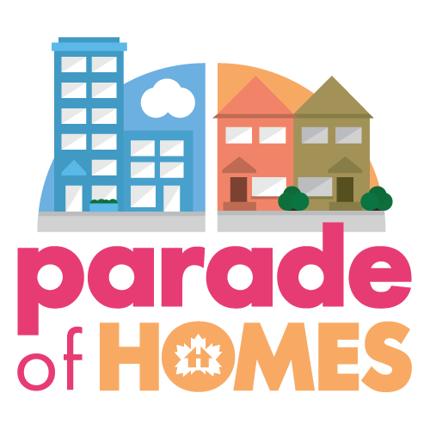
What do the logo and branding signify?
The new logo is designed to be bright, clean, simple, and recognizable. The wordmark features the Canadian Homebuilders’ Association’s trademark house and leaf, used to reflect that the Parade of Homes features members of the Saskatoon & Region Home Builders’ Association.

Accompanying the wordmark are illustrations of four different types of homes: a single family house, acreage, townhouse, and apartment style condo. These illustrations are designed to reflect the theme of “choice.” The show homes in this year’s parade offer consumers a diverse choice of home style, community, and lifestyle.

Is this not a challenging time to look at homes in Saskatoon?
It’s important to make informed and educated decisions when it comes to what is for many, the most important investment of their lives. We would never qualify Saskatoon as a challenging place to do business or to own a home. Quite the contrary, the parade demonstrates the choice, the quality and the options available in our beautiful city. Each family or individual has a different story, needs and wants, and it’s important to keep that in mind when looking for a home. We always suggest to hire and surround yourself with qualified professionals you trust and SRHBA builders are just that. You know you can get a quality, safe home for years to come, for what fits your situation best. Their minimum standards are higher, they adhere to Professional Home Builder Certification standards and they are very busy making quality homes for Saskatoon.

What can people expect when they visit homes build by SRHBA members - What is there to see?
The homes in the Parade of Homes are show homes, so they will all be fully furnished and fully decorated. This means that in addition to seeing homes which are built to the high quality standards required of SRHBA members, you’re also going to see the latest trends in décor and finishings.

Is the Parade of Homes on social media?

Yes! Please follow us! Our accounts are:
Facebook: | facebook.com/pohYXE
Instagram: | instagram.com/pohYXE
Twitter: | @pohYXE

Show your friends how you try on each home, each neighborhood and what you like about it. Share with us your favorite décors , your favorite layouts and features.

Who should I contact for more information on the Parade of Homes?
For more information, please contact:
Krystal Rudyk
Communications Manager
Saskatoon & Region Home Builders’ Association
T: 306-955-5188 E: communications@saskatoonhomebuilders.com

